PRT661

Energy Demand Forecasting System
Data Acquisition, File Management and Preprocessing Documentation

Purpose: provide a reproducible and understandable record of how project data is acquired, organised, validated and prepared for the later forecasting pipeline.

Document Control
Item | Description
Primary implementation file | Data_Acquisition final.py
Primary acquisition sources | AEMO NEM/WEM sources, AEMO dashboard API, Bureau of Meteorology data and Australian public-holiday calendars
Default acquisition start | 2022-01-01
Default acquisition end | Current date at runtime
Demand regions | NSW1, QLD1, VIC1, SA1, TAS1, WA
Feature regions in current script | NSW1, QLD1, VIC1, SA1, TAS1, WA, NT (NT features only; no NT demand file)
Primary raw folders | price_and_demand, energy_requirement, dispatch, predispatch, bom_weather, public_holidays

Executive Summary
The PRT661 Energy Demand Forecasting project uses a multi-source data pipeline to collect electricity demand and market information together with weather and public-holiday drivers. The objective of this design is to create a defensible raw-data foundation for later forecasting, rather than mixing downloading, manual editing, preprocessing and modelling in a single step.
The acquisition program retrieves historical NEM price-and-demand files, constructs a combined WA/SWIS operational-demand history, downloads a separate 2026 WA market-requirements file, captures current NEM dispatch and pre-dispatch snapshots, obtains daily BOM weather variables, and generates state-specific public-holiday calendars. Each output is written to a dedicated folder so that the raw layer remains understandable and auditable.
A key engineering decision is the preservation of WA source frequency. Legacy WA demand uses 30-minute observations through September 2023, while newer WEM data uses 5-minute observations from October 2023. The acquisition program preserves this distinction and records SOURCE_INTERVAL_MIN instead of inventing 5-minute historical values. A later preprocessing stage should harmonise the data to a modelling frequency that does not create artificial observations.
The recommended architecture separates raw, interim and processed data. Raw files remain unchanged evidence; interim files contain validated and harmonised tables; processed files contain feature-engineered datasets ready for forecasting. This separation improves reproducibility, reduces accidental data corruption and makes the final analytical workflow easier to explain and test.

Contents
1. Purpose and Scope
2. End-to-End Pipeline Architecture
3. File Management Strategy
4. Region and Source Configuration
5. Data Acquisition Workflow
6. Dataset Inventory and Evidence
7. Acquisition-Stage Data Quality Controls
8. Preprocessing Design
9. Feature Engineering and Modelling Dataset
10. 2026 Forecasting and Validation Strategy
11. Reproducibility and Operational Use
12. Risks, Limitations and Controls
13. Recommended Next Implementation
14. Conclusion
Appendix A. Runtime Options
Appendix B. Function Reference
Appendix C. Core Data Dictionary

1. Purpose and Scope
This document records the full data-handling process surrounding the current PRT661 acquisition pipeline. It explains where the data comes from, how the Python program retrieves it, how files are organised, what quality controls are already applied during ingestion, and how the raw outputs should be transformed in the next preprocessing stage.

1.1 Objectives
- Create a repeatable data-acquisition workflow for electricity-demand forecasting.
- Keep raw source data separated by purpose and region so that files remain easy to trace.
- Preserve source-specific characteristics, particularly WA interval frequency and data provenance.
- Provide enough validation during ingestion to prevent obvious malformed or duplicate records from silently propagating.
- Define a clear boundary between raw acquisition and modelling preprocessing.
- Establish a data-management structure that can support later model training, validation and dashboard reporting.

1.2 Scope of the Current Python File
The implementation file contains six main acquisition activities: AEMO dashboard snapshots, monthly NEM historical archives, WA operational demand, 2026 WA market requirements, BOM weather, and public-holiday calendars.

2. End-to-End Pipeline Architecture
The project is best understood as a sequence of controlled layers. External sources are first ingested into a raw directory. Validation and preprocessing then convert those raw outputs into harmonised intermediate data. Feature engineering creates modelling-ready tables, after which forecasting, evaluation and dashboard reporting are performed.
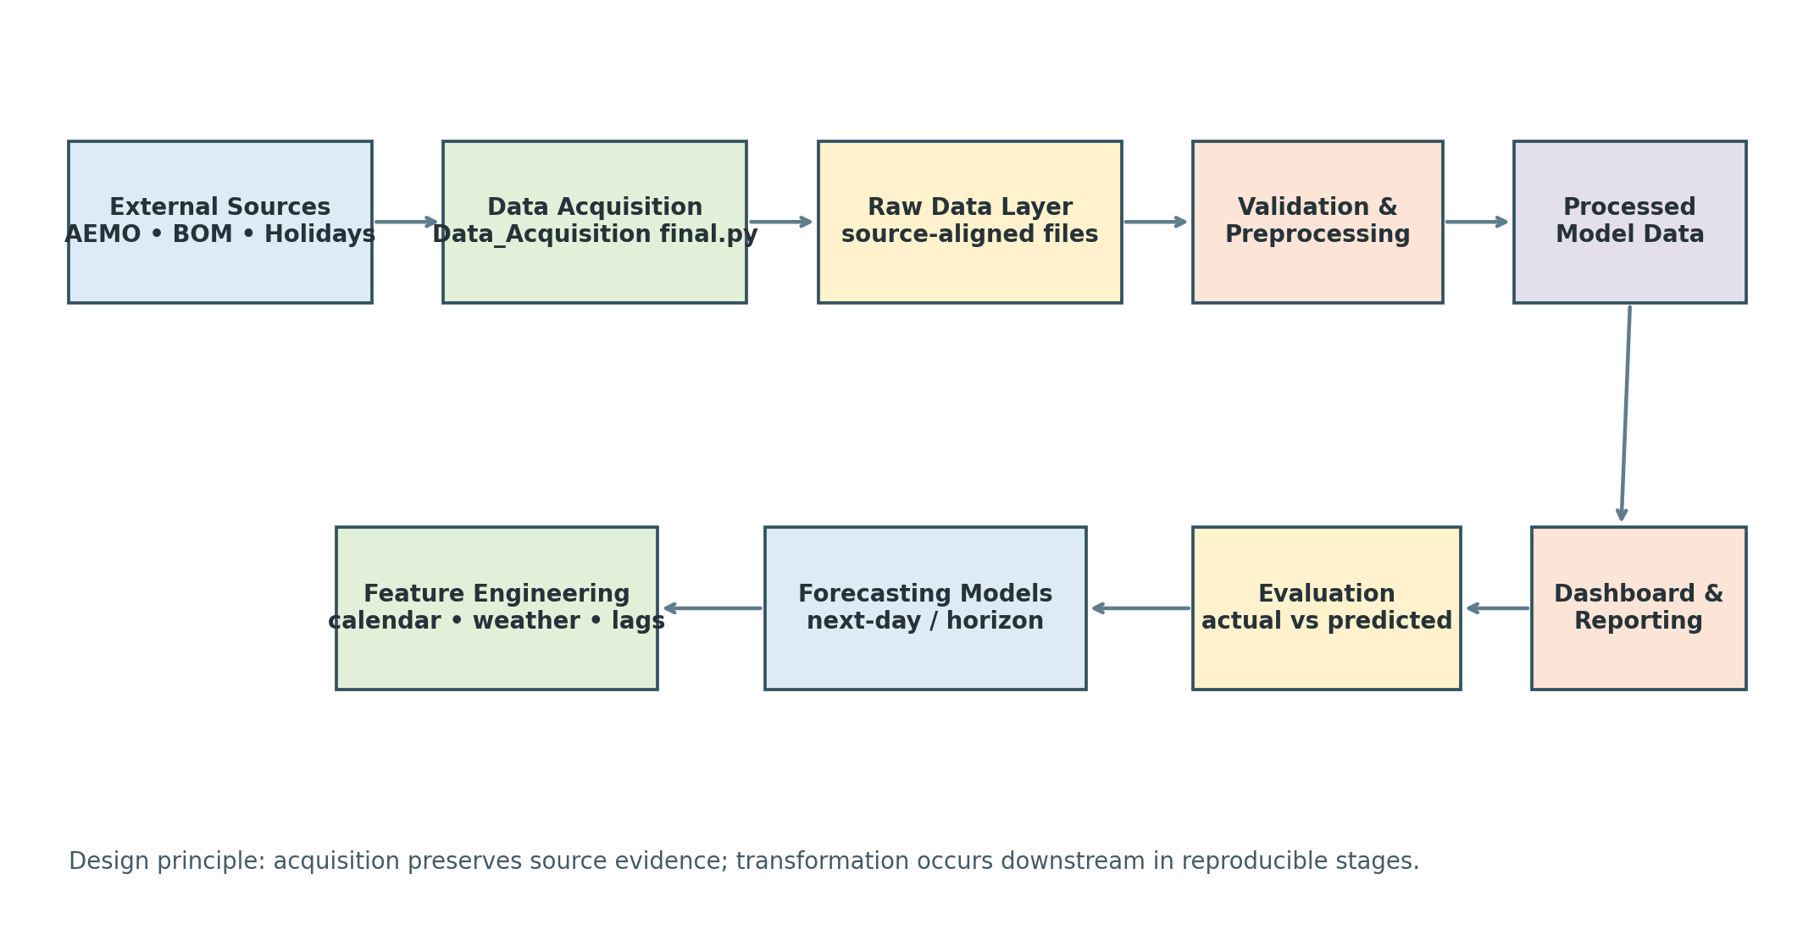
Figure 1. Recommended end-to-end architecture for the PRT661 forecasting pipeline.
Stage | Primary responsibility | Typical output
Acquisition | Download and capture source data; preserve provenance | Raw CSV/JSON-derived files
Raw storage | Maintain source evidence without manual edits | data/raw/...
Validation / preprocessing | Check schema, timestamps, duplicates, missingness, time zones and frequency | data/interim/...
Feature engineering | Create calendar, weather, lag and rolling features | data/processed/...
Forecasting | Train and generate future demand predictions | models/ and outputs/forecasts/
Evaluation | Compare predictions with known actual demand | outputs/metrics/ and validation tables
Reporting | Present trends, forecasts and model performance | dashboard/ and figures

3. File Management Strategy
The current raw directory already separates files by function. This should be retained and extended into a three-layer data structure: raw, interim and processed. This design prevents source files from being overwritten during experimentation and makes every modelling dataset reproducible from the original acquisition outputs.
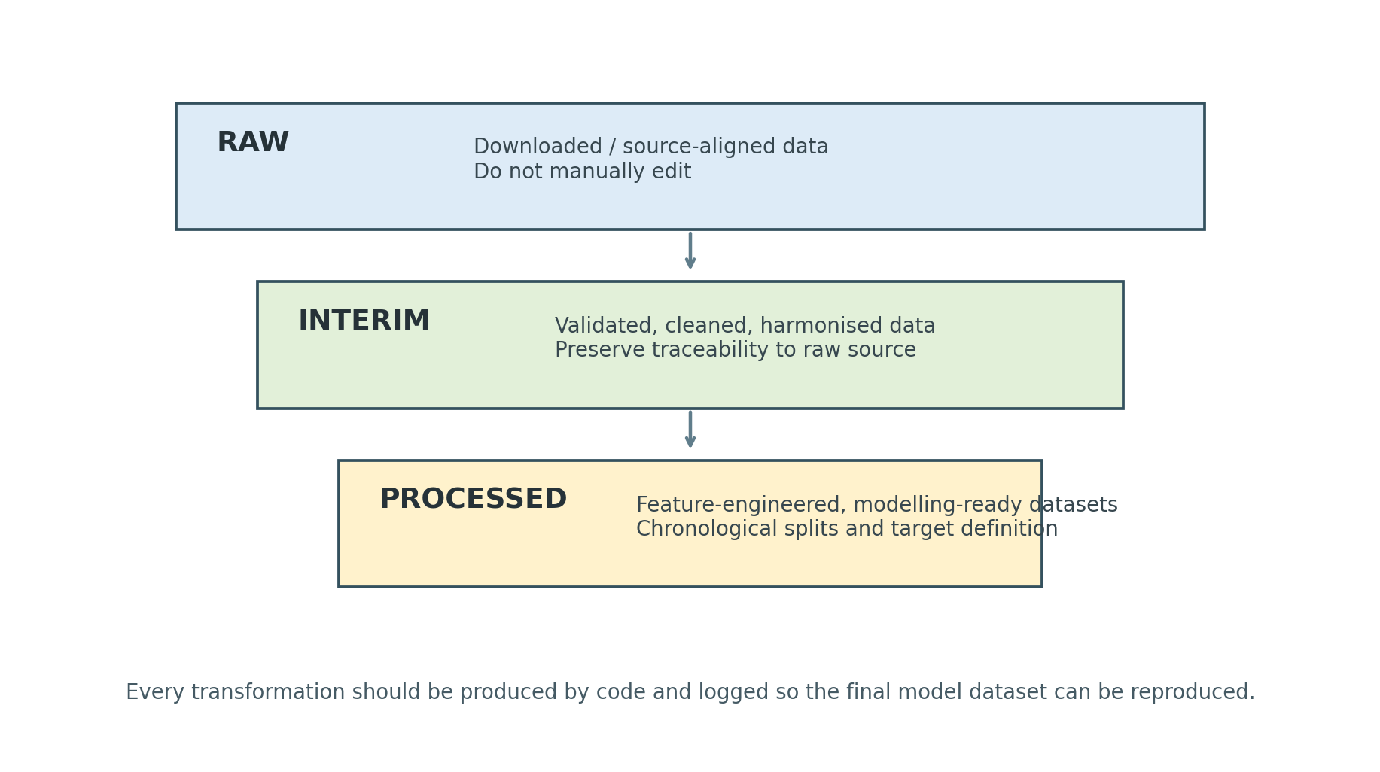
Figure 2. Raw, interim and processed data layers.

3.1 Current Raw Directory
Raw Dataset/
├── price_and_demand/
├── energy_requirement/
├── dispatch/
├── predispatch/
├── bom_weather/
└── public_holidays/

4. Region and Source Configuration
The Python file differentiates demand regions from feature regions. Historical demand is available for the five NEM regions plus WA. The current implementation also collects NT weather and holiday features even though it does not acquire an NT demand series.
Region | State / market | Representative BOM station | Role in current script
NSW1 | New South Wales / NEM | 066062 – Sydney (Observatory Hill) | Demand + weather + holidays
QLD1 | Queensland / NEM | 040913 – Brisbane | Demand + weather + holidays
VIC1 | Victoria / NEM | 086338 – Melbourne (Olympic Park) | Demand + weather + holidays
SA1 | South Australia / NEM | 023034 – Adelaide (Airport) | Demand + weather + holidays
TAS1 | Tasmania / NEM | 094029 – Hobart (Ellerslie Road) | Demand + weather + holidays
WA | Western Australia / WEM | 009021 – Perth Airport | Demand + weather + holidays
NT | Northern Territory | 014015 – Darwin Airport | Weather + holidays only in current script

5.5 WA 2026 Market Requirements
MarketRequirements-2026.csv is downloaded separately from operational demand and written unchanged to the energy_requirement folder. Keeping this file separate avoids confusing a market-requirements dataset with observed demand. Its variables can later be assessed for validation, contextual analysis or feature use, depending on the final modelling design.

5.6 BOM Weather Acquisition
For each feature region, the program uses a configured BOM station and requests three daily products: maximum temperature, minimum temperature and rainfall. Each variable is stored in a separate CSV so that the raw response remains easy to trace to its source and station.
- Maximum temperature – product code 122
- Minimum temperature – product code 123
- Rainfall – product code 136
During preprocessing, these separate daily files should be standardised and merged into a regional weather table keyed by local date and region.

5.7 Public-Holiday Calendars
The public-holiday stage generates one daily calendar per region/state across the requested date range. Each file contains the date, a binary public-holiday indicator and the holiday name. This creates reproducible calendar features without manually maintaining holiday spreadsheets.
Field | Meaning
date | Calendar date across the requested range
is_public_holiday | 1 when the date is a public holiday for the state; otherwise 0
holiday_name | Name returned by the holiday calendar when applicable

6. Dataset Inventory and Evidence
The following screenshots document the current output structure produced during acquisition. They are useful as implementation evidence because they show that the acquisition logic creates separate folders and region-specific outputs rather than a single unmanaged data dump.
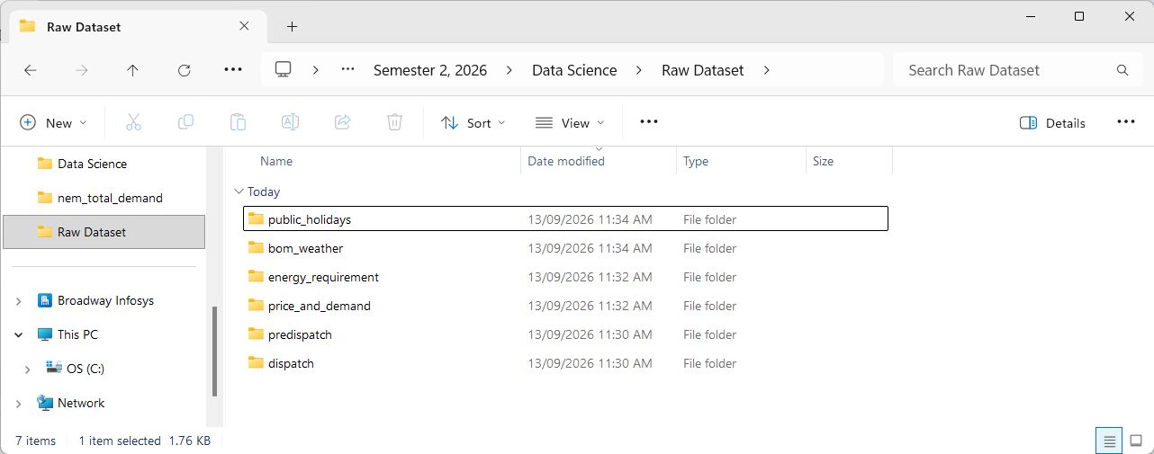
Figure 3. Current Raw Dataset directory showing the six acquisition categories.
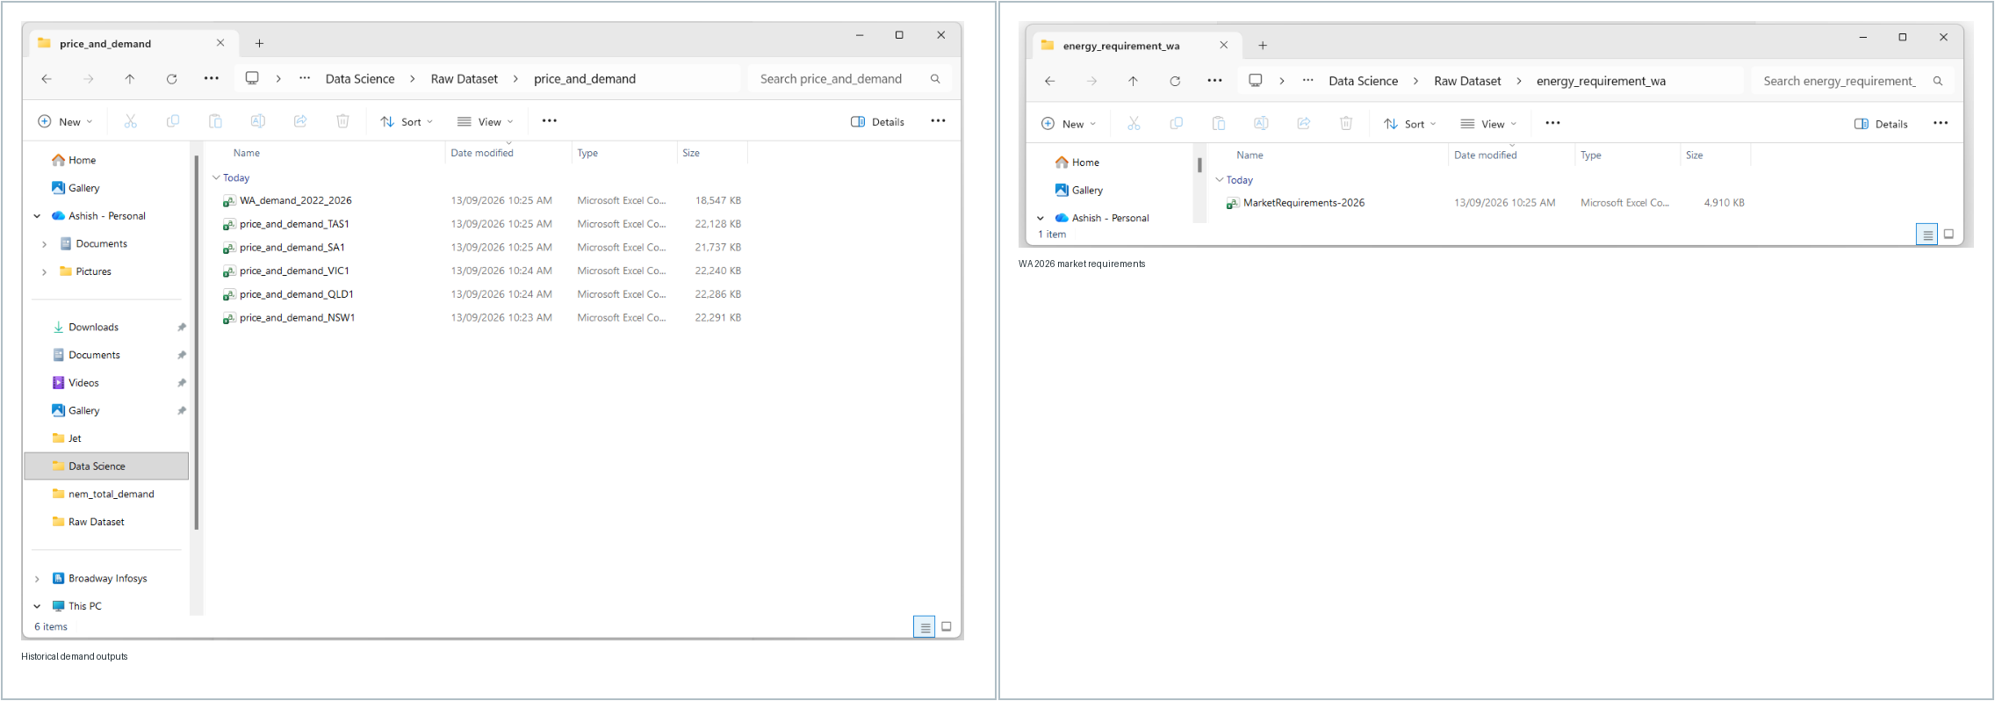
Figure 4. Historical price-and-demand outputs and the separate WA 2026 market-requirements file.
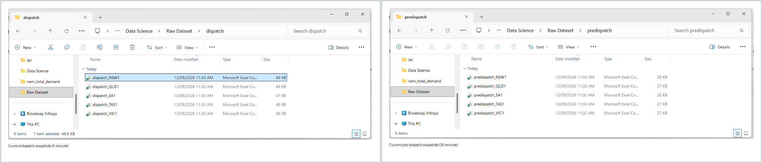
Figure 5. Region-specific dispatch and pre-dispatch snapshots produced from the AEMO dashboard API.
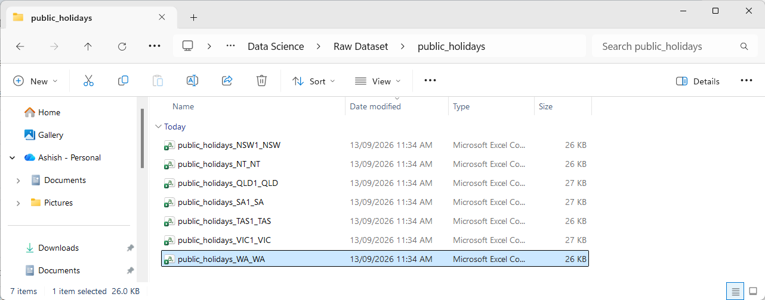
Figure 6. Public-holiday output files by region/state in the current acquisition run.

7. Acquisition-Stage Data Quality Controls
The acquisition layer applies only the controls required to create reliable raw outputs. It avoids aggressive analytical cleaning because raw data should remain traceable to its source.
Control | Where applied | Purpose
HTTP status / response checks | AEMO and BOM requests | Reject failed responses and obvious HTML error pages
Timestamp parsing | NEM and WA inputs | Recognise multiple timestamp formats and identify usable records
Chronological sorting | Historical demand outputs | Maintain a consistent time order
Duplicate timestamp removal | NEM monthly concatenation and WA source overlaps | Prevent repeated intervals
Numeric demand checks | WA demand-column identification | Avoid selecting non-numeric demand-like fields
Source priority | WA legacy/modern/daily overlaps | Keep the most appropriate record for overlapping timestamps
Date-range filtering | WA combined output | Restrict results to requested acquisition window
Step-level exception isolation | All acquisition stages | Allow the rest of the pipeline to continue after source failure
Provenance fields | WA normalisation | Retain SOURCE and SOURCE_INTERVAL_MIN

